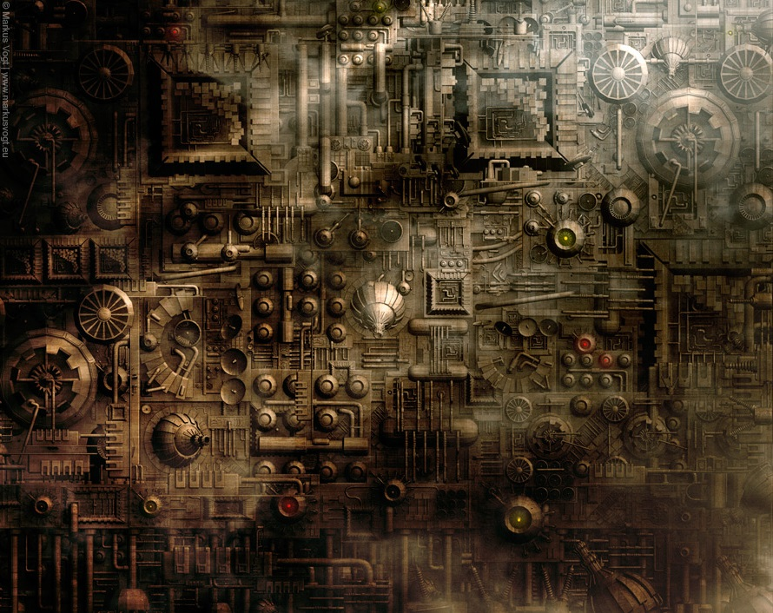

|  |  |
| --- | --- |
| **Synopsis**  A blind and badly damaged Robot tries to find its way out of an automated factory in orbit around Earth using only sound waves to identify its surroundings. A top down 2D game | **Rules**  Player can be seen at all times but the rest of the world can only be seen briefly after each pulse of sound. With zero gravity, the Player gathers momentum quickly using thrusters. Hitting any walls or obstacles can destroy the player and resets that level. |
| **Features**  In order to "see" the player emits a pulse of sound that lights up a cone of vision in the direction the player is moving. Procedurally generated levels make each playthrough unique. The robot uses jetpack mechanics to move in the Zero-G environment. | **Goals**  The player must complete each level by negotiating several connected rooms packed with obstacles. The main goal would be to beat each level as quickly as possible and gain freedom. |
| **Theme**  An industrialized automated factory. A myriad of factory based obstacles and traps to catch the player out such as Stamping Machines, Spinning Sawblades, Moving Laser Wires, Gravity Wells. Narrow pipelines between rooms. | **Pace**  The aim is to complete each level quickly. This is made challenging with limited vision and the various hazards the player needs to negotiate. |

|  |  |
| --- | --- |
| **Target**  Targeted at hardcore gamers who enjoy a challenge due to the difficulty of the game and the patience to master the movement and timing. Players who enjoy difficult games like Super Meat Boy and Spelunky. | **Interface**  Arrow keys to use thrusters on the x and y axis to move the player. Analog stick on the controller. |

Each level procedurally generates 4 different rooms connected via pipes. Each room is different from the last and one room contains the level exit. The player must find the exit as quickly as possible.

Evocative minimalist art style a la Limbo and Sunless Sea.

